Noack op. 67 (1973)

One Manual (divided keyboard, treble and bass)
Hook-down pedal (flat and parallel)

$15,000

Organ Dimensions
- Height: 10’6”
- Width: 5’1”
- Main Case Depth: 2’9”
- Total Depth: 5’9” (includes pedalboard)

Organ History and notes

- Commissioned by Dr. James A. Fenimore for his residence in Houston, this one-manual tracker organ features divided stop action. The instrument has casters enabling it to be rolled away from the wall for service. The case is oak with a tin façade and gold-leaf pipe shades, hand carved by the late Fritz Noack. The manual features ebony keys and the hook-down pedal is flat and parallel.
- The blower is located in the case and runs on regular house current.
- The organ has been cared for by Steuart Goodwin, organ builder since it arrived in Redlands. It is in excellent condition.
- The organ is being replaced by a new, larger two-manual pipe organ designed by Steuart Goodwin.

- the organ is on the main floor of the sanctuary. There is a single door adjacent to the organ area that leads outside to a flat concrete area next to the circle drive.
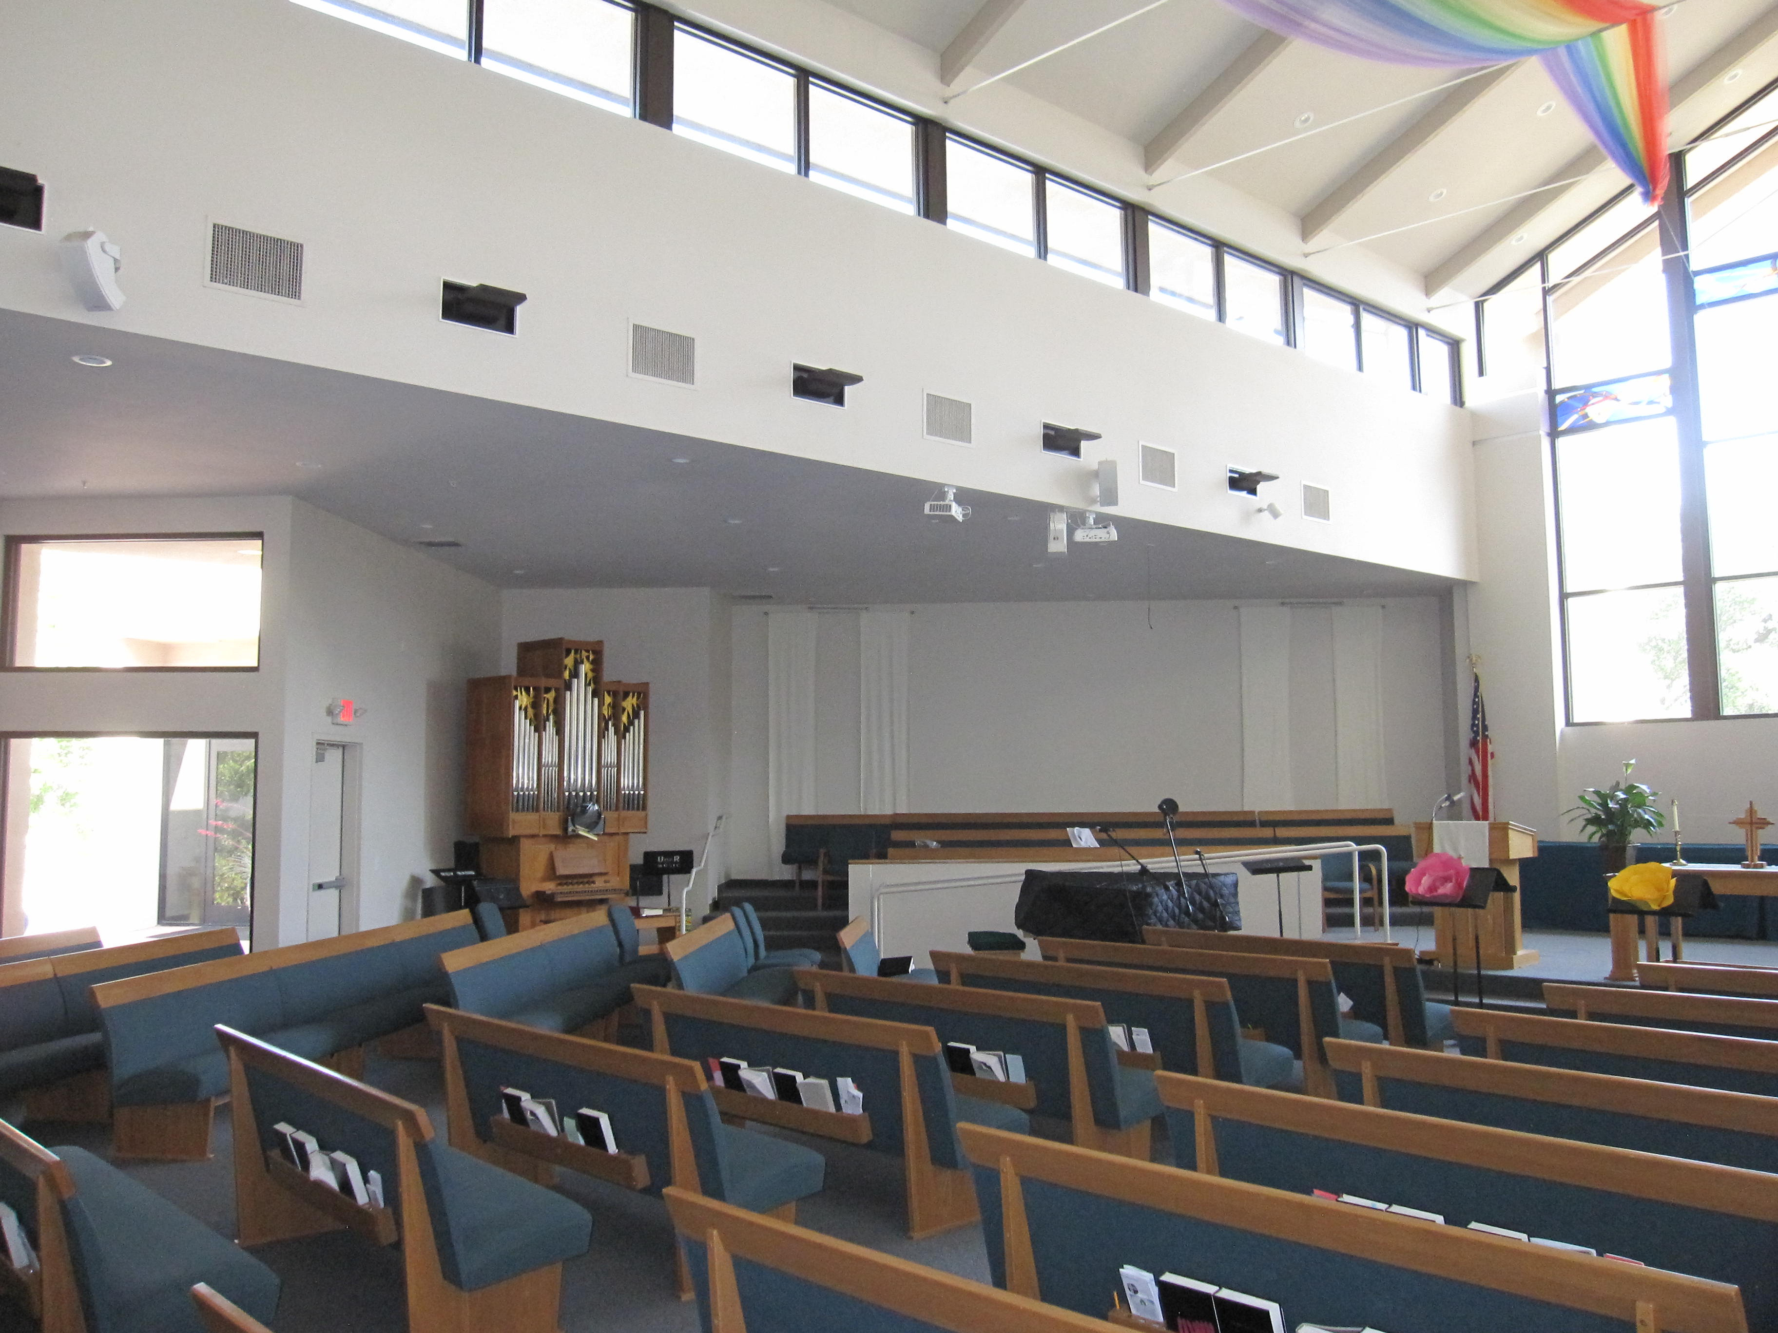
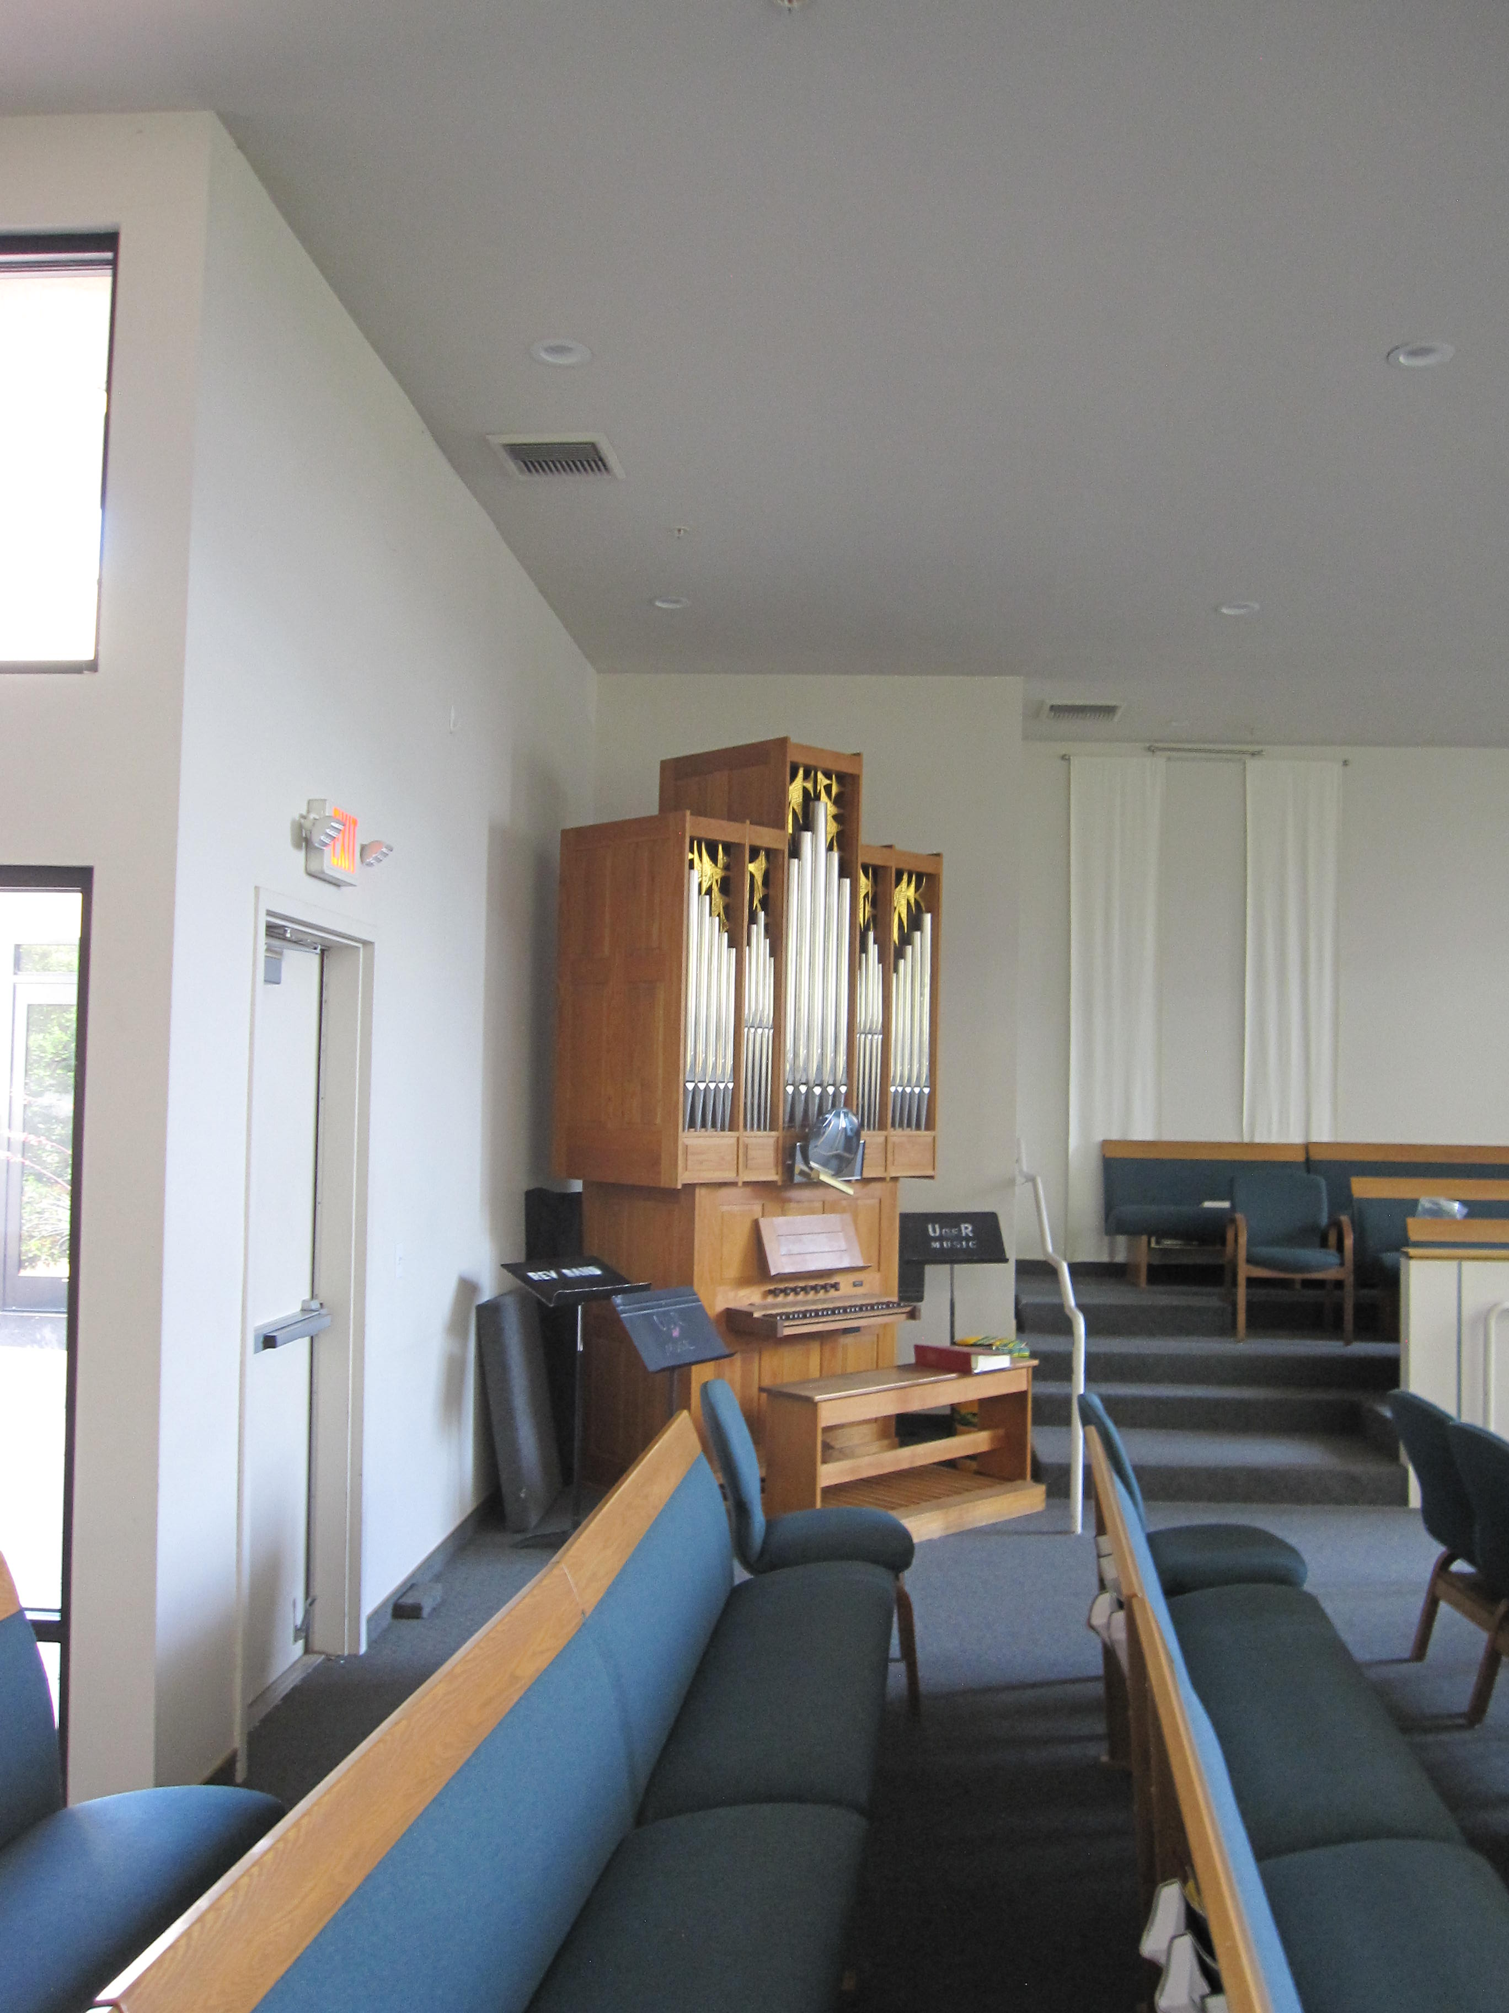
- There are also double doors in the back of the sanctuary that lead to a narthex and then out to the circle drive.
- The sanctuary is handicapped accessible (no stairs)
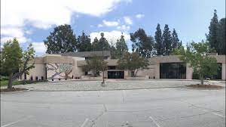
The Sanctuary building from the circle drive and parking lot
The church has been advised of the conditions of sale.

Here is a flyer that appeared in the AGO newsletter for the Los Angeles AGO.

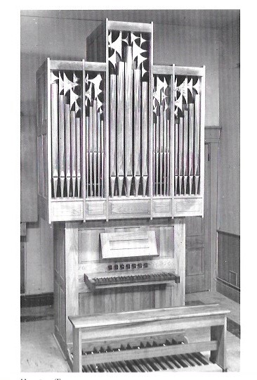
For Sale
Noack, op. 67, 1973*

Manual (C-g3*)

Gedackt 8’ B/T
Principal 4’ B/T
Chimney Flute 4’ B/T
Nazard 2-2/3’ B/T
Octave 2’ B/T
Mixture II-III B/T
Krummhorn 8’ B/T

Mechanical Action
Pulldown pedal C-f1

*as listed in Die Orgelbewegung in Amerika, (Pape Verlag, Berlin, 1977)

Commissioned by Dr. James A. Fenimore for his residence in Houston, this one-manual tracker organ features divided stop action. The instrument has casters enabling it to be rolled away from the wall for service. The case is oak with a tin façade and gold-leaf pipe shades, hand carved by the late Fritz Noack. The manual features ebony keys and the hook-down pedal is flat and parallel.

